Lab 7 Submission

Accepting input & producing expected results
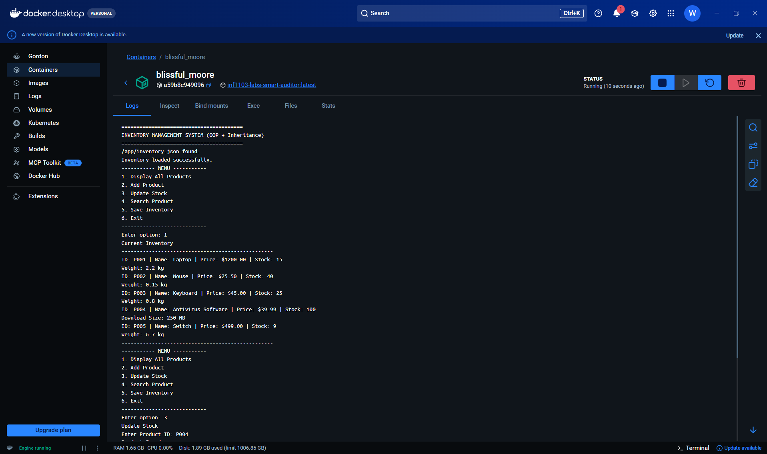

Docker Container


